Midterm Progress Report

On

Garbage Management System



Submitted by

Pushpita Patil 15CO235

Sai Priya 15CO116

Prabhat Bhattarai 13CO234

**Introduction**

We are implementing Internet-of-things (IOT) project to track the status of various dustbins and developing an efficient algorithm to collect the garbage. With the use of an Arduino, server and end client dashboards written in C we plan to implement a smart garbage management system. We plan to improve timely collection of garbage and the efficiency of routes taken by garbage collectors.

**Literature Survey**

Due to widespread adoption of IOT as field for novel innovation we have seen many practical uses of IOT. One of such implementation is Smart Garbage Management System. Now we look at the research conducted in this field.

In the paper: Top-k Query based dynamic scheduling for IoT-enabled small city waste collection, Anagnostopoulos, Zaslavsky, Medvedev and Khoruzhnicov have implemented efficient pickup of garbage by using sensors and actuators along with an effective scheduling for garbage pickups.

In the paper: City Garbage collection indicator using RF(Zigbee) and GSM technology,

GSM technology is used to send status of dustbins to a central server.

IoT-Based Smart Garbage System for Efficient Food Waste Management by Insung Hong, Sunghoi Park, Beomseok Lee, Jaekeun Lee, Daebeom Jeong, and Sehyun Park implements IOT based Smart Garbage System (SGS) to replace RFID-based garbage collection systems.

Smart Waste Collection System Based on Location Intelligence, practically demonstrates how Internet of Things (IoT) integration with data access networks, Geographic Information Systems (GIS), combinatorial optimization, and electronic engineering can contribute to improve cities’ management systems. Ultrasonic Ranging Module was used as a sensor and Arduino Uno was used as a microcontroller.

So, the main aim of our project is to improve the efficiency of garbage collection, prevent overloading of garbage bins and to take a step towards clean and environment friendly city.

**Design**

We are using Infrared (IR) Sensors attached to an Arduino to detect the height of garbage in a dustbin. We also have a button attached to an arduino that should be pressed to schedule a pickup of garbage from a home.

We are using a C program on the Arduino to communicate with a server also written in C. We will create a dashboard for Garbage Collectors which shows an efficient route to take while collecting garbage.

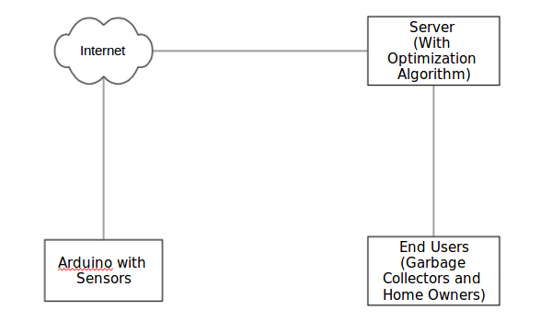

**Implementation Details**

We will have infrared/ultrasound sensors connected to an arduino attached to the top of dustbins to measure garbage height. Arduino will send the sensor’s data to a local server written in C.

**Work done so far**

We have worked on Arduino with infrared sensors to detect the heights of dustbins (almost completed).

**Work to do**

We have to finish the coding of the program in Arduino. Then, we have to code the server and end-user dashboards.